Sequence Diagram

Administrator gets the request for Issuing a Certificate

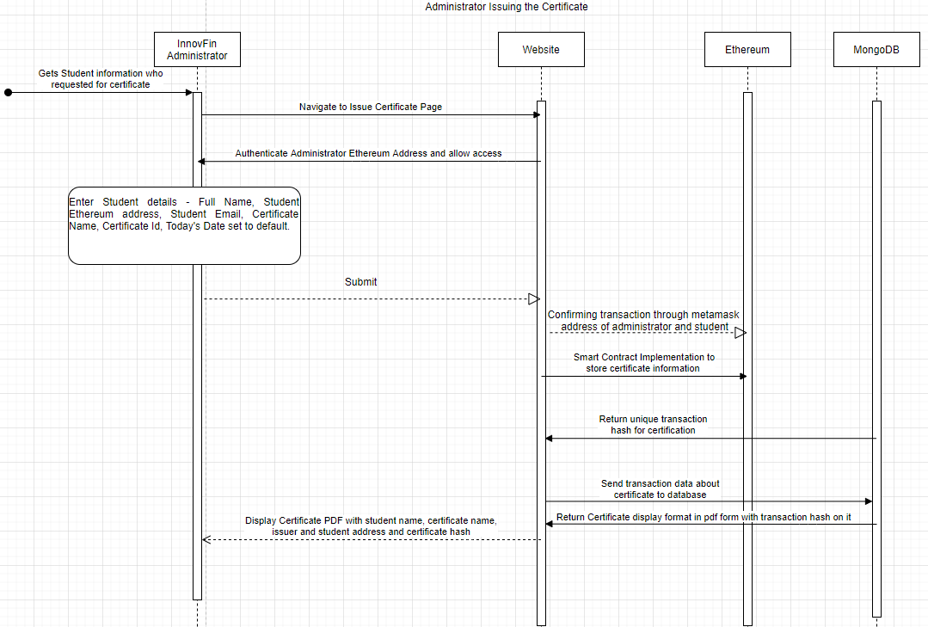

Student receives hash and goes to verification of certificate

